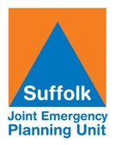

Chevington, Suffolk Community Emergency/Resilience Plan

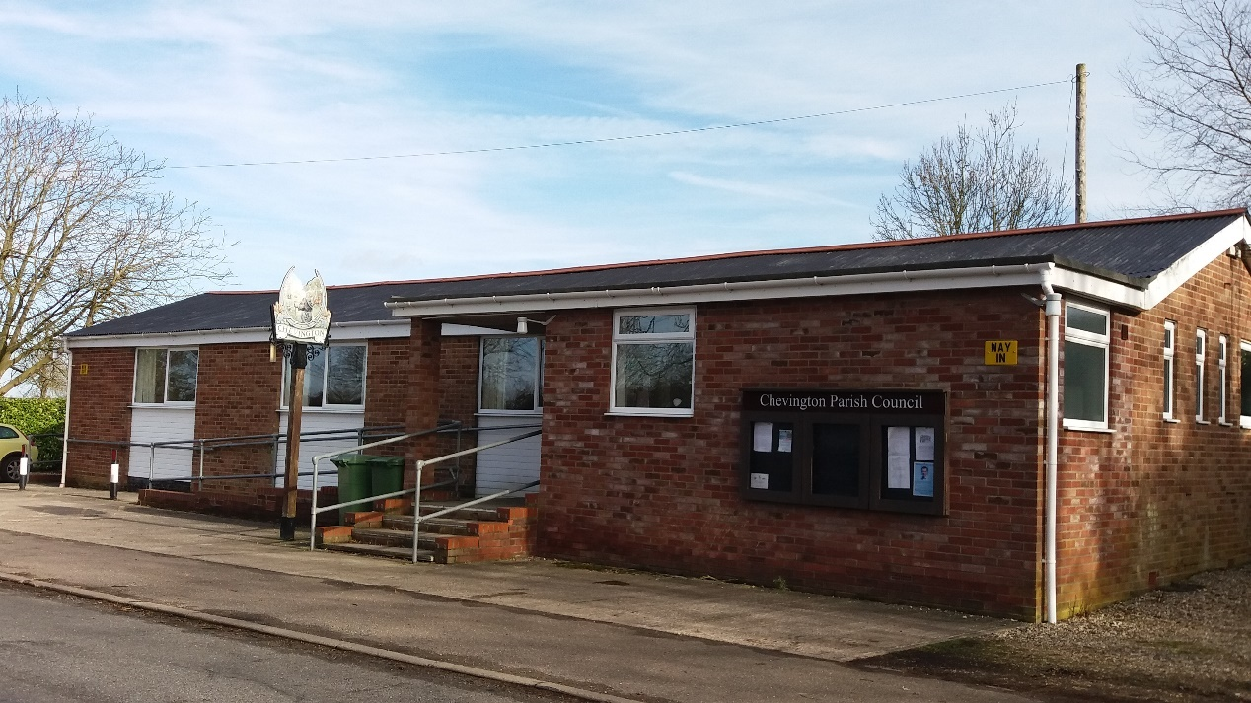

The Community Emergency Planning (CEP) concept aims to encourage local communities to develop Community Emergency Planning Groups (CEPGs) and Community Emergency Plans for their localities.
It is envisaged that once established, CEPGs will be able to support their local community, the local authority, emergency services and other agencies during an incident.
A CEPG may be formed from a Parish or Town Council as well as by groups who are not associated with a Parish of Town Council.

Suffolk Joint Emergency Planning Unit
The Suffolk Joint Emergency Planning Unit (JEPU) is a local authority partnership that supports the delivery of civil preparedness and business continuity services within the six local authorities in Suffolk.
The Suffolk JEPU staff are based both in the districts and borough, and centrally with Suffolk County Council. This enables them to provide the subject matter expertise, planning, training and advice to officers and councillors to facilitate civil preparedness capability within each council.
The JEPU also provides the local authority interface with the wider Suffolk Resilience Forum.
Suffolk Resilience Forum
Suffolk Resilience Forum is the principal mechanism for multi-agency cooperation under the Civil Contingencies Act 2004 and its boundaries are based on local policing boundaries. It is a multi-agency group that helps to coordinate activity in our county in planning, preparing, responding to, and recovering from major incidents.
The aim of this guidance is to provide you with a starting point for the development of your plan. Examples shown in this guidance are drawn from national guidance or where we have seen good examples in existing Community Emergency Plans.
JEPU can provide support in the development of your Community Emergency Plan, this is available by contacting your local Emergency Planning Officer (EPO).
District/Borough | Name | Contact Number (office hours only) | Email
Babergh & Mid Suffolk | Freddie Gulliver  Ben Wilding | 01473 260947  01284 758462 | Emergency.planning@suffolk.gov.uk
East Suffolk | Peter Langford  Courtney Walsh  Amy Langley | 01473 265321 | Emergency.planning@suffolk.gov.uk
West Suffolk | Ben Wilding  Freddie Gulliver  Tarik Foley | 01284 758462  01473 260947  01284 758461 | Emergency.planning@suffolk.gov.uk

Author | Parish Clerk
Date of Publication | August 2024
Review | August 2025
Version | Version 3

EMERGENCY PLAN CONTACT NUMBERS FOR CHEVINGTON, SUFFOLK. IP29
2024
Parish Council Contacts: | Cllr Alastair McCormack, 01284 850277 Mrs Frances Betts 01284 810508 (Clerk has all contact details for current Parish Councillors)
Landowners/Farmers  Tree Surgeon | Redacted in this copy  Clerk has all details on file
Other organisations

PLACE OF SAFETY TO BE USED IN AN EMERGENCY SITUATION
Everyone can find these buildings in the village

- The Village Hall will be the primary centre for contact and co-ordination of activity in the case of an emergency
- The Parish Church will be the secondary centre for contact and co-ordination of activity in the case of an emergency
- The Greyhound Public House will be the third centre for contact and co-ordination of activity in the case of an emergency
- The Erskine Centre in Chedburgh will be the fourth centre for contact and co-ordination

KEY HOLDERS
Pam Nichols 01284 850277 | The Parish Clerk 01284 810508
Alastair McCormack 01284 850277
Simon Williams 01284 850045
Bill Down 01284 850421

POTENTIAL EMERGENCY SITUATIONS
Multiple vehicle accident on A143 | Really bad snow storm cutting off the village
Catastrophic electricity failure throughout village lasting more than 12 hours | Hostage situation involving weapons
Catastrophic failure to the water system throughout the village lasting more than 12 hours | Plane falling from sky
Large lorry fire causing big explosion somewhere in the village | Multiple house fires causing road closures for more than 12 hours

EQUIPMENT AVAILABLE
The village hall has:
Is a known location for all parishioners | Heating
Toilets | A Telephone
A fully equipped kitchen | Tables and chairs
Parking

The Parish Church has:
Heating | Seating
Is dry | Has lighting
Is easy to get to | Has parking
Has a toilet | Tea making facilities

The Greyhound Pub has:
- Heating | - A fully licenced kitchen
- Electrics | - Is dry
- Is central to the village | - Has parking space
- Easy to get to and leave | - Tables and chairs
- Toilets | - Is staffed
- The Erskine Centre has:
- Heating | - Is dry
- Electrics | - Has tables and chairs
- Fully equipped kitchen | - Has lots of parking spaces
- Toilets | - Has a telephone

Ensure these few basic things are available

• A Torch in working order with fresh and spare batteries. There are wind up models available; they just need a periodic shake. If you have to use candles place them in a container or lantern and never leave unattended. Night-lights are safer and remember the matches.
• A battery or windup Radio. This may be the only source of entertainment as well as getting news of progress of supplies being restored. Cars have batteries and radios.
• A Landline telephone (preferably served by underground cable) - mobiles may not work after about 2 hours as the repeater standby batteries discharge. The service may be overloaded and access restricted by the supplier. Your handset batteries will also discharge during use.
- Some alternative heating source independent of mains electricity.
- Some method of boiling a kettle or saucepan.
- A Thermos flask
- Some standby tinned or dried food
- Residents volunteering food, cooked, but frozen that can be defrosted in time to help feed people.
- Note books and pencils/pens

Plan Validation
The village organised a series of meetings to discuss the plan via the Parish Council meetings Autumn 2024
Incident or Exercise | Reason for Activation | Key Learning
Public meetings | To discuss how the plan would work and for a talk-through of plan in context of scenario | For all Councillors to know about the plan and to identify how to communicate this to the parishioners.

RESILIENCE PLAN
Aim
To enhance the resilience of the parishioners of Chevington in Suffolk through developing our local emergency preparedness, response and recovery arrangements which align with local responders and reduce the impact of the incident on our communities.
Objectives
- To understand our local risks/hazards
- To consider possible mitigation for the risks/hazards identified
- To assist our residents in being prepared for emergencies
- To identify and map our local resources and capabilities including volunteers
- To plan our local response arrangements to incidents
- To ensure we have effective communication mechanisms in place between emergency responders and the Town/Parish Council and between the Town/Parish Council and our local communities.
Chevington Parish Council will include discussions regarding resilience for the village in their published Parish Council meetings during Autumn and early Winter 2024. This will lead to several articles in their local Benefice magazine (delivered to every household) so that all parishioners can think about their own resilience if an emergency occurs.

Risks | Impact on community | What can the CEPG do to prepare? | What can the CEPG do to respond?
Examples:  Flooding:  - Surface Water run-off,  - River (Fluvial)  - Coastal  - Ground Water | Example -  - Flooding of local streets  - Damage to property  - Blocked access to Community Centre | - Refer to flood risk map Check the long term flood risk for an area in England - GOV.UK (www.gov.uk).  - Identify local flood risk areas, find out what flood defences exist or are planned in the area – Work with the Environment Agency on flood aspects of your Community Emergency Plan. Contact your local EPO if you are unsure how to contact them.  - Sign up as a Parish/Town Council to receive Flood Warnings from the Environment Agency – Sign up  - Sign up as a Parish/Town Council to receive Met Office Weather Warnings (Guide to email alert service - Met Office)  - Encourage residents to review and improve home flood defences and sign up to receive Flood Warnings as individual households (Flooding - Suffolk Resilience Forum (suffolkprepared.co.uk))  - Identify local shelters (Rest Centres) should residents need to evacuate their properties  - Work with local emergency responders to see if you or they can help with distribution of flood warnings and any evacuation and Rest Centre establishment required  - Encourage local people to put together ‘Get Prepared Bags’ and Household Plans - Prepare yourself - Suffolk Resilience Forum (suffolkprepared.co.uk) | - Warn and inform – consider how you might cascade information to residents following receipt of Flood Warnings or Met Office Weather Warnings directly or following information from your local authority.  - Consider Emergency Information Points.  - Follow your Flood Action Card (work with the Environment Agency to develop these).  - Open local shelters as Rest Centres (see Activation section).  - Place ‘Flood’ warning advisory signage in areas pre-agreed with Suffolk Highways. See Community Self-Help Scheme - Suffolk County Council for further information.
Power Outage | - Heating homes  - Cooking and food preparation  - Communication  - Impacts on water supply | - Encourage people who may be in vulnerable circumstances to sign up to the UK Power Networks Priority Services Register (PSR) - About the Priority Services Register | UK power networks  - Encourage local people to put together ‘Get Prepared Bags’ and Household Plans - Prepare yourself - Suffolk Resilience Forum (suffolkprepared.co.uk) | - Warn and inform – consider how you might cascade information received directly from UKPN or following information from your local authority to local residents.  - Consider Emergency Information Points.  - Open local shelters as Rest Centres (see Activation section).
Water Outage | - Access to drinking water | - Encourage people who may be in vulnerable circumstances to sign up to their water company’s Priority Services Register (PSR) (see Suffolk Prepared for more information)  - Work with your local EPO to identify water distribution locations. Contact your EPO for further information. | - Warn and inform – consider how you might cascade information received directly from water companies or following information from your local authority to local residents.  - Consider Emergency Information Points.  - Open local shelters as Rest Centres (see Activation section).

Generic Risk Response
This section is where you should record your generic initial steps as there are certain steps that you should consider in your plan to assist your response whatever the circumstances of the incident may be. These steps include:
- Assessing local impacts when safe to do so, utilising information from as many sources as possible to give you the best understanding of the incident (see ‘Assessing the impact of the incident’ below).
- Alert Emergency Services if, and as, applicable to ensure they are aware, (always call 999 if life threatening).
- Convene Community Emergency Plan Coordinators and decide activation of Community Emergency Plan.
- Determine local response steps, i.e., warning and informing residents, setting up a Rest Centre or Emergency Information Point.
- Advise District Council if you have activated or are considering activating your local Community Emergency Plan.
- Inform District Council that your Emergency Coordination Group is on standby to support if required. Please see ‘Activation’ section for information about office hour contact and out of hours contact with local authority Emergency Planning Officers.
- Consider pre-determined specific risk-based activity – i.e., following steps on Flood Action Card such as placement of ‘Flood’ warning advisory signage (see Suffolk Highways Community Self-Help Scheme – more information in Local Risk Assessment section above)

A suggested checklist for the Emergency Coordination Group to use is available at Annex 2.

Assessing the impact of the incident
An assessment of the incident severity should be undertaken as quickly as possible. It is of the highest importance to ensure that no one puts themselves at risk whilst this assessment is being undertaken.
Remember - In the event of any local emergency, if there is ANY threat to life, dial 999 and alert the emergency services.
The objective of this type of assessment is to determine whether there is a need to activate your plan, monitor the situation or remain in a ‘business-as-usual’ state.
‘METHANE’ is the recognised common model for passing incident information between services and their control rooms. All local authority incident responders in Suffolk use the ‘METHANE’ model to capture information and your CEPG can use elements of this too to help collate the right information.
Consider assessing the incident using the following:
M | Major incident | Has a Major Incident been declared? | This is not a question that CEPGs need to answer but is included for your awareness.
E | Exact Location | What is the exact location or geographical area of incident? | Use road names, post codes or grid references. What3Words would also be a good way to understand exactly where an incident is.
T | Type of Incident | What kind of incident is it?
H | Hazards | What hazards or potential hazards can be identified? What has caused the problem? How has it happened? Are there any secondary hazards to be considered?
A | Access | What are the best routes for emergency services and responders for access and egress?
N | Number of casualties | How many casualties are there and what condition are they in?
E | Emergency Services | Which and how many emergency responder assets/personnel are required or are already on-scene? | This is not a question that CEPGs need to answer but is included for your awareness.

Generic Risk Assessment Information for roles/activity
Whatever role individuals undertake, appropriate and where necessary dynamic risk assessments should be carried out, prior to any task, to ensure all volunteers are not exposed to any unnecessary risks.
Consideration of appropriate personal protective equipment should be undertaken e.g., reflective jacket, suitable footwear, checking in, working in pairs etc. AT NO POINT SHOULD ANYONE PUT THEMSELVES, OR OTHERS AT RISK OF DANGER.
Risk Assessments are a continuous process and should reflect the changes in circumstances e.g., incident duration, feeding or providing overnight accommodation.
To carry out a risk assessment, you need to firstly identify what the hazards are and then look at the risks associated with those hazards.
A hazard is anything that may cause harm, e.g., chemicals, electricity, working from ladders, noise etc.
Risk is the likelihood (high, medium or low) of somebody being harmed by the hazard, and how serious the harm could be.
It is important to calculate what the risk is before conducting activity, and to think about and record what, if anything, can be done to minimise the risk, and therefore whether it’s safe for you to proceed with your actions.
An example Risk Assessment template is provided at Annex 5. Other templates are available including those which can be found on the Health and Safety Executive website (Risk assessment: Template and examples - HSE).
An adapted version of the ‘METHANE’ form that your CEPG may wish to use is available at Annex 1.
Completing this form will allow you to make an informed decision with other Community Emergency Plan Coordinators as to if your plan should be activated or not. It will also assist you to capture the information to pass to the local authority Emergency Planning Officer. The person completing this form must be objective and not get absorbed into a response until the initial information has been ascertained.
Activation
Your Community Emergency Plan needs to have clear directions as to how it is activated and who by.
Community Emergency Plans may be activated as follows:
- Self-Activation by your CEPG, or for example, in response to a request from a member of the public or because of an event such as severe weather
- A request from your local authority
- A request from the Emergency Services
Activation by Community Emergency Planning Groups
If your CEPG determines to activate its own plan, without a request from the Emergency Services, or the local authority, then you are acting under either your own Community Group’s liability insurance (if you have any), or that of your Town or Parish Council if covered.
It is the responsibility of your CEPG to ensure that you have insurance cover prior to activating your plan.
Ideally, the decision to activate your plan should involve a minimum of two people (for example, the people listed with the District Council as the primary and secondary contacts) conferring and making a decision. If the decision is made to activate the plan, these two people will form the Emergency Coordination Group (ECG). More members of your Community Emergency Planning Group may join the ECG following activation of your plan.
Before you as a CEPG activate your plan, it’s important that you have sufficient information available regarding the incident and have considered any triggers that might prompt you to activate your plan i.e., Amber or Red Weather Warnings, flood experience etc.
This will ensure that you are able to review the risks that may affect your community and have the capability to carry out the actions requested.
Where there is a heightened risk, your local Emergency Planning Officer (EPO) should ensure that you are aware of Suffolk Resilience Forum (SRF) activities. In the absence of any information from the local authority, any local assessment should be carried out when it is safe to do so.
If your CEPG self-activates you must inform your District Council as soon as possible via the normal District Council relevant contact number (this may be a different number for out of hours). This enables the EPO to understand your local situation, offer advice or liaise with other responders to support you or provide you with estimated recovery times e.g., loss of power. In and out of hours contact numbers for your relevant District Council should be included within the key contacts section of your plan.

Activation by a Responding Agency
If directly activated by the Emergency Services, the same details should be obtained by the CEPG from the activating agency.
It is important that in the first instance your CEPG notes the name of the person you have notified that your plan has been activated, the time that you made that call as well as ensuring that the person you have spoken to has your contact details.
If your District Council agrees that your CEPG should continue with their activation, this will be confirmed by telephone followed by a ‘Community Emergency Planning Group Activation Form’ sent to the email address that you provide. This will confirm the activities that your CEPG have been tasked to do by the local authority and therefore which activities you are covered to conduct under local authority insurance.
If your local authority does not authorise your CEPG to continue with activation of your plan and/or activities, you will be informed via email and telephone and any further CEPG activity will NOT be covered by the local authority insurance.
Activation by a Local Authority
Activation of your Community Emergency Plan may also be requested by the local authority.
It is therefore important that the relevant local authority holds the contact details for at least two members of your CEPG, a primary and a secondary contact which they can use to call if they need to activate your CEPG.
When requesting a CEPG to activate their plan, contact will normally be made by telephone to the primary, secondary or routine contact person that has been provided to the Joint Emergency Planning Unit. It is important that the officer requesting activation of the CEP is clear on what support/activities need to be undertaken by the CEPG and that this is confirmed by the completion of the Community Emergency Planning Group Activation Form.
The type of support that a CEPG can offer does vary considerably but may take the form of:
a. Opening and operating a Rest Centre
b. Supporting the Local Authority with staffing within a Rest Centre
c. Warning and informing their community
d. Supporting the emergency services during evacuation process
e. Offering local knowledge of the area affected
It is important that once activated a CEPG is aware of the District Council’s Emergency Control Centre (ECC) contact number. The ECC & CEPGs need to ensure that regular updates are shared between them.
The below is suggested wording for you to include in the ‘Activation’ section of your plan.
In the event of any local emergency, if there is ANY threat to life, dial 999 and alert the emergency services. If there is no perceived threat to life, but you have information that may help the emergency services, please dial 101.
The Plan will be activated in one of two ways:
- The …….. Community Emergency Planning Group may make the decision to activate our plan, for example in response to a request from a member of the public or because of an event such as severe weather.
- The ……. Community Emergency Plan may be activated, following a call from the local authority or the emergency services in response to a major incident.

The decision to activate the ……. Community Emergency Plan should be made by a minimum of two people from the ........Community Emergency Planning Group (details held in Annex...) conferring and making a decision.
In the event that the ………. Community Emergency Planning Group decides to activate its own plan, without a request from the Emergency Services or the local authority, then we are acting under the Parish/Town Council’s(other) liability insurance until such time as the local authority has been informed and has agreed to the Emergency Plan being activated. Therefore, the local authority should be contacted at the earliest opportunity in the following ways:
West Suffolk Council
During office hours call 01284 763233 and request a call back from an Emergency Planning Officer.
Out of hours call West Suffolk Council on 01284 763252 and request a call back from the Emergency Planning Duty Officer.
Note - In a widespread incident Emergency Planning Officers may be supporting the local authority response across the county and may not be able to respond to you immediately.
Activation by Local Authority or a Responding AgenIn some circumstances, Community Emergency Planning Groups will be contacted by their local District Council requesting activation of their Community Emergency Plan for specific activities to support the response to an incident. Following the telephone call the District Council will email a ‘Community Emergency Planning Group Activation Form’ which will confirm the tasks that the Community Emergency Planning Group has been asked to conduct and confirmation of how only these tasks are covered by the local authority’s insurance.
If directly activated by the Emergency Services, the same details should be obtained by the CEPG from the activating agency.

Insurance
It is important that CEPGs have the correct insurance cover. In this section list the insurance policy references for your own Parish/Town Council and note if there are any references under the public liability section that may support any volunteer or emergency response processes/activities.
Roles and Responsibilities
Note: The likely cover under local authority insurance is as follows:
The Community Emergency Planning Group (CEPG) and CEPG volunteers will be covered by West Suffolk Council’s insurance under the following circumstances;

- West Suffolk Council has requested you activate your plan and volunteer group
- The CEPG volunteers are registered with the CEPG
- The CEPG and CEPG volunteers are under the direction of a local authority member of staff (this can be remotely), and the local authority receives regular updates of task progress/issues arising from the CEPG
- They only carry out the actions/activities that they have been authorised to do or agreed by the local authority
- A record of the activities undertaken and volunteers employed in those tasks is maintained by the CEPG
- Activities they have been asked to undertake must be commensurate to their skills and competency
- Appropriate dynamic risk assessments are carried out
- The use of motor vehicles is not covered by the local authority’s insurance and it is the responsibility of the individual to ensure that they have adequate and appropriate cover.

If you undertake activities that are not authorised by West Suffolk Council then you need to determine whether your local Parish/Town Council’s insurance policy covers these activities.
The Emergency Coordinating Group (ECG)

The role of the ECG is to organise the activities of your CEPG during an emergency by assessing the situation, mobilising the appropriate local resources to support the community, and maintaining links with the local authority, emergency services and other responding organisations. Typical tasks associated with this may include the following roles:

Community Coordinator(s)
Members of the ECG may be allocated areas or zones within the Parish or Town to coordinate supporting volunteers in the response by doing tasks such as warning and informing local residents through door-to-door engagement. Full contact details of the Community Coordinators should be placed in the key contacts directory of your plan.

Rest Centre Coordinator
The person(s) undertaking this role should have attended a local authority run Rest Centre course (see the Events page on the SRF website for training dates - suffolkprepared.co.uk) and is/are responsible for maintaining the safety and welfare of those residents and volunteers using the Rest Centre and should be in accordance with the local authority procedures. The local authority must be advised when a Rest Centre is provided so as to provide appropriate support at the earliest opportunity. Full contact details of the Rest Centre Coordinators should be placed in the key contacts directory of your plan. All the forms necessary for running a Rest Centre can be found on the SRF website.

Information Coordinator
One member of the ECG should be responsible for making sure all the Emergency Information Points have the same information to avoid confusion. This person would be the ideal link to communicate with the local authority Emergency Control Centre (ECC). Full contact details of the Information Coordinators should be placed in the key contacts directory of your plan.

Community Locations

Refer to local risk assessments with regards to any vulnerable community locations.

Coordination Centre Locations
When the ECG forms in response to an emergency, the coordination activity may take place in a Coordination Centre.
This is simply a location where the ECG can meet and manage your community’s response to the emergency. This may be someone’s home, a room in the village hall or another similar location. Ideally, the venue should have access to a phone and to kitchen and toilet facilities. You should identify some venues in advance and list them, along with the contact details for accessing them during an emergency.
Full contact details, addresses and availability of the Coordination Centres should be placed in the key contacts directory.

Emergency Information Points
Locations can be pre-identified to pass information to the community during an emergency; these could be places such as community centres, the Post Office, local shops, or local notice boards.
If the Parish/Town council have a website or access to social networking sites these can be very useful in keeping everyone informed of the latest situation.
Full contact details, addresses of the Emergency Information Points should be placed in the key contacts directory.

Rest Centre(s)
A Rest Centre is simply a location where people can go when there is an emergency; whether it is to keep them warm and dry or somewhere to discuss actions that need to be taken. This may be the village hall, community centre or another similar location. Ideally, the venue should have access to a phone and to kitchen and toilet facilities. You should identify some venues in advance and list them in a table, along with the contact details for accessing them during an emergency.
Suffolk Joint Emergency Planning Unit Emergency Planning Officers may have already assessed venues in your area for use as a designated local authority Rest Centre. Check with your local EPO whether particular venues have already been assessed.

Note - Details of the emergency Rest Centres may be shared with the emergency services in case they need to identify a safe location to evacuate residents to.

Community Locations at Risk

Cross reference to local risk assessments with regards to vulnerable locations dependent on weather related conditions e.g., Rest Centre built in a flood plain.
Emergency Box
Your CEPG may wish to create an Emergency Box to assist you with the coordination of your local response. This box should contain relevant information and equipment that you might need during an emergency. Information or equipment held in the box should be updated and checked regularly. Depending on the size of your community or number of Community Coordination Centres, you might want to think about having more than one box.
Make sure your CEPG know the location of your emergency box and how to access it.
Your Emergency box might include the following, however, please note this list is not exhaustive:
- A copy of this plan
- A street map, flood map, postcode data, or zone areas for area coordinators
- A logbook (it is important to record any decisions that you make in case you need to review these at a later stage or provide them for any inquiry or investigation. You should record what information you had at the time that prompted you to make a decision and the considerations that you made)
- Paper, pens and general stationery items
- Wind up/battery operated radio/torches
- Reflective Jackets/waistcoats
- Basic First Aid Kit
- Walkie talkies
Please ensure that you are complying with UK General Data Protection Regulations when recording and storing information.

Debrief
Debriefing is a discussion that revolves around the sharing and examining of information after a specific event has taken place. A ‘Hot Debrief’ should take place by the key people involved in an incident at shift handovers and immediately after the incident has passed and a “Cold Debrief” should be held at a later date once things are getting back to normal. This should be open to anyone involved in the incident. It enables you to record what went well, what could have been better so that you can learn from this experience to improve things next time.
You should consider setting out a process for how and where you will undertake a debrief, who will record the notes and how these will be reflected in your plan, and who will make any changes.

Annexes
The following pages are suggested annexes that you may want to include within your plan. These are not exhaustive and there may be other annexes that you wish to include such as action cards for specific risks, risk assessment tools, Rest Centre forms, warning and informing action cards (i.e., prepared scripts for volunteers to use when speaking with local residents), debrief template forms etc.

Annex 1 – METHANE template
M | Major incident | Has a Major Incident been declared? | This is not a question that CEPGs need to answer but is included for your awareness.
E | Exact Location | What is the exact location or geographical area of incident?
T | Type of Incident | What kind of incident is it?
H | Hazards | What hazards or potential hazards can be identified? What has caused the problem? How has it happened? Are there any secondary hazards to be considered?
A | Access | What are the best routes for emergency services and responders for access and egress?
N | Number of casualties | How many casualties are there and what condition are they in?
E | Emergency Services | Which and how many emergency responder assets/personnel are required or are already on-scene? | This is not a question that CEPGs need to answer but is included for your awareness.

Annex 2 - Emergency Coordination Group Checklist
The following is a list of general actions that your ECG might undertake if your plan is activated.
In the event of any local emergency, if there is ANY threat to life, dial 999 and alert the emergency services.
Inform the local authority that you have activated or are looking to activate your plan

Gather as much information about the situation as possible when it is safe to do so and consider which local resources could be mobilised to support the community including establishment of a Rest Centre to provide some immediate shelter if people have had to leave their homes . Consider using the METHANE template at Annex 1.

Consider whether you can work safely and effectively from your current location, or whether it is safe to move to an alternate location.

Notify other members of your ECG and request that they meet at the nominated location if safe to do so and instigate the call cascade as necessary.

Tune into local radio and listen for updates on the emergency. Follow any emergency services advice issued.

Tell your community that your emergency team is functioning.

Arrange for contact to be made with the vulnerable members of the community as appropriate and arrange for advice/assistance to be offered.

Arrange for the community resources/organisations identified to be made available as necessary.

Consider asking for additional members of the community (volunteers) to help with the response, you may have identified Community Coordinators already. Tasks may include door knocking to warn and inform residents.

Follow any Action Cards for specific risks

Check your email system regularly.

Consider establishing contact with neighbouring Parish/Town Councils and ask for/offer support if appropriate.

Ensure that any members of your community engaged in the response are not putting themselves at risk. Make sure they are acting lawfully, carefully and are not carrying out tasks and activities that they are not qualified to do.

General Data Protection Regulations
Community Emergency Planning Groups including those established by Parish and Town Councils and those that are not associated with Parish or Town Councils must adhere to UK General Data Protection Regulations. Further information can be found from the Information Commissions Office - UK GDPR guidance and resources | ICO

Agency | Name | Normal Hours | Out of Hours
Suffolk Fire & Rescue |  | 01473 260588
Suffolk Police |  | 101 | 101
East of England Ambulance Service |  | 0345 601 3733
NHS 111 |  | 111 | 111
Maritime Coastguard Agency |  | 0203 817 2000
Suffolk Joint Emergency Planning Unit (JEPU) |  | 01473 265321
EPO East Suffolk (JEPU) | Amy Langley | 01473 265423
EPO Ipswich (JEPU) | Courtney Walsh | 01473 265321
EPO BMSDC (JEPU) | Freddie Gulliver | 01473 260947
EPO West Suffolk (JEPU) | Tarik Foley | 01284 758461
District Emergency Planning Manager - East & Ipswich | Peter Langford | 01473 265321
District Emergency Planning Manager - BMSDC & West | Ben Wilding | 01284 758462
UK Power Networks | Power Cuts 24/7 | 0800 31 63 105 or 105 | 0800 31 63 105 or 105
Suffolk County Council Highways |  | 0345 606 6167
National Highways | General Enquiries | 0300 123 5000
Suffolk Trading Standards |  | 0808 223 1133
Children & Young People (CYP) |  | 0800 917 1109
Adult Care Services (ACS) |  | 0800 917 1109
Anglian Water | Water Supply & Sewerage Enquiries | 03457 145 145 | 03457 145 145
Gas (National Grid) | Smell of gas or emergencies | 0800 111 999 | 0800 111 999
External Contact Details
Not to be used in the case of an emergency. If there is risk to life dial 999
Met Office |  | 0370 900 0100 | www.metoffice.gov.uk
Environment Agency  enquiries@environment-agency.gov.uk | Floodline | 0345 988 1188 or  0845 988 1188 | 0345 988 1188 or  0845 988 1188
Environment Agency  enquiries@environment-agency.gov.uk | Incident hotline | 0800 80 70 60 | 0800 80 70 60

Annex 4 - Example of Telephone Cascade Tree
Person who finds out about the incident

Emergency Coordinator 2 (E.g., could also be secondary contact for Local Authority)
Emergency Coordinator 1 (E.g., could also be primary contact for Local Authority)
Emergency Coordinator 3
Person 31
Person 32
Person 33 etc.
Person 34
Person 35
Person 36 etc.
Person 28
Person 29
Person 30 etc.
Person 2
Person 10
Person 11
Person 12
Person 3
Person 7
Person 9
Person 8
Person 1
Person 16
Person 17
Person 18 etc.
Person 13
Person 14
Person 15
Person 6
Person 5
Person 25
Person 26
Person 27 etc.
Person 22
Person 23
Person 24 etc.
Person 4
Person 19
Person 20
Person 21

Annex 5 – Example Risk Assessment Template

Location |  |  |  |  | Date: |  |  |  | Review date:
Risk Assessors Name: |  |  |  |  | Job title:
Task / Hazard Identified | No of persons at risk |  |  | What is risk? | Risk rating
Task / Hazard Identified |  |  |  |  | I | L | Risk | Action to remedy
Impact multiplied by Likelihood = Risk Rating: 16 = Very High, 8-12 = High, 4-6 = Medium, 0-3 = Low

Note - If you undertake activities that are not authorised by the District Council then you need to determine whether your local Parish/Town Council’s insurance policy covers these activities.

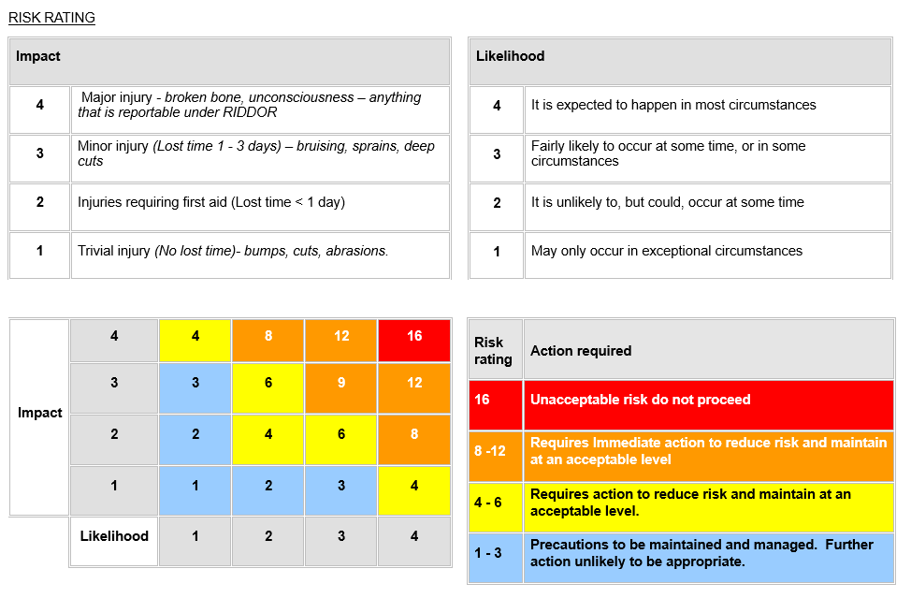

Glossary
CEP Community Emergency Plan
CEPG Community Emergency Planning Group
CRR Community Risk Register
DEPM District Emergency Planning Manager
EA Environment Agency
ECC Emergency Control Centre (Local Authority)
ECG Emergency Coordination Group
EPO Emergency Planning Officer
EPDO Emergency Planning Duty Officer (from JEPU)
JEPU (Suffolk) Joint Emergency Planning Unit
RC Rest Centre
SRF Suffolk Resilience Forum

