@KarenSoons

@KarenSoonsforWestSuffolk

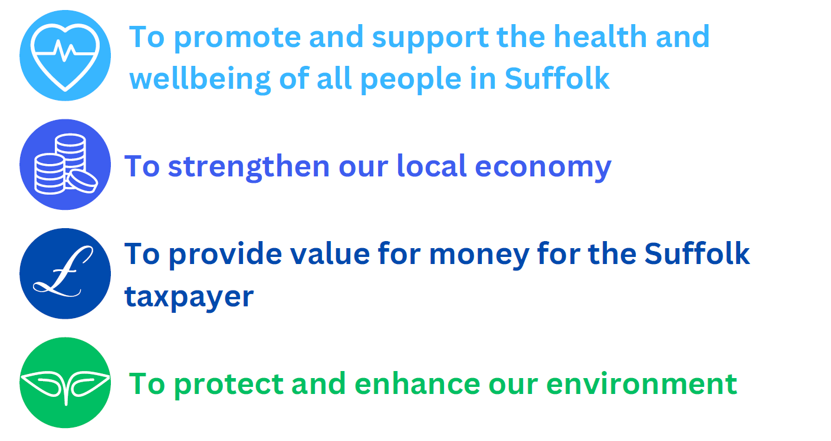
 @karensoons1
Cllr Karen Soons

07864 601 887
karen.soons@suffolk.gov.uk
September 2023 Parish Newsletter

Contents

Page 3 - Suffolk Trading Standards unveils its 200th No Cold Calling zone
A scheme to protect the elderly and vulnerable from unscrupulous cold callers sees its 200th opening in Kessingland.

Page 4 - Trading Standards urge £765,000 fraudster to give himself up for sentencing
Wayne Parker has been on the run since February after being found guilty of fraudulent trading.

Page 5 - Award Success for Social Care in Suffolk
Suffolk County Council staff and teams have been recognised for their achievements and skills by being shortlisted at the Social Worker of the Year Awards.

Page 6 - Formal opening of £1.3 million Suffolk Fire and Rescue Service training centre
A new-look training centre at Wattisham Flying Station for Suffolk firefighters has been formally opened.

Page 7 - Council fears new energy proposals will harm Suffolk’s coastline
Southwold and Walberswick could be affected by new proposals for onshore cabling, as part of a large international project to connect offshore wind power in the North Sea.

Suffolk Trading Standards unveils its 200th No Cold Calling zone
Residents in Kessingland, near Lowestoft, have become the 200th community in the county to be part of a No Cold Calling Zone.
The zone covers 96 properties in Hall Road, The Fellowship Green, Solomon Road and Maram Green, as part of a scheme run by Suffolk Trading Standards that works to make people feel safer in their homes.
The zone was chosen by a Trading Standards officer after a resident was fleeced of more than £8,000 by a rogue trader who called at their door.
The trader offered to clean the gutters for £30, which was agreed.
However, upon starting the work they then claimed there was a broken tile on the roof, crumbling roof felt, and the timber was damaged by water, and the resident ended up paying £8,150 by cheque.
Despite investigations, the trader was never traced although intelligence has been shared with other Trading Standards authorities and safeguarding is now in place for the victim, with their bank and family.
The new zone was formally launched with tea and cakes in a gathering of residents, councillors and police at the offices of Kessingland parish council.
Councillor Andrew Reid, Suffolk County Council Cabinet Member for Public Health and Public Protection, said:
“Doorstep cold callers can often turn out to be unscrupulous people who prey on the elderly and vulnerable in their homes, the very place where they should feel safest.

“No Cold Calling Zones work to deter that from happening by making it clear that residents in that zone will not deal with any trader who knocks on their door out of the blue.

“I applaud the hard work of the community and the organisers on coming together in this way. These zones are proven to have a deterrent effect and I am delighted that we now have 200 such schemes in place.”
A No Cold Calling Zone (NCCZ) is a nominated area where residents state they do not want traders to cold call at their homes.
They are set up if they meet criteria such as incidents of doorstep crime or distraction burglary, are a population more susceptible to doorstep crime, and are within a defined geographic area.
Residents in the nominated NCCZ area are consulted and with their agreement a NCCZ is set up and an information pack, door sticker and street signage provided.
Trading Standards have set up the zones across Suffolk in partnership with residents, councillors, police, and partners.
The zones have been designed to:
- Reduce doorstep crime and distraction burglaries
- Deter cold callers
- Educate residents and empower them not to engage with cold callers
The first zone was launched in Maryon Road and Grasmere Close in Ipswich in 2009 and there are now more than 9,700 properties in Suffolk covered by them.
Anyone wishing to nominate their road should go to the No Cold Calling page on the Suffolk County Council website.

Trading Standards urge £765,000 fraudster to give himself up for sentencing
Suffolk Trading Standards is appealing to the public for help as they urge a man wanted for failing to appear in court for sentencing for fraudulent trading to hand himself in.
Wayne Parker, of Mildenhall, was found guilty in October 2022 of obtaining more than £765,000 in credit from suppliers.
He presented himself as a livestock owner which enabled him to be given credit by a wide range of companies. He often made no attempt to settle his debts and, when he did, repeatedly sent cheques that would bounce.
An arrest warrant was issued when he failed to appear in court in February 2023.
Since going on the run Mr Parker is known to have been using the Match.com dating website and has also been hiring cars in a bid, it is believed, to avoid detection by the police.
He has links to west London, with his last known address being in Feltham, however, he has carried out work across Suffolk, Norfolk, Cambridgeshire, and Surrey.
Recent intelligence suggests that he may also be working in Wales and there are links to him being in Somerset.
Graham Crisp, Head of Suffolk Trading Standards, said:
“Mr Parker has repeatedly said he would return to Suffolk to face the consequences of his actions but, so far, he has failed to do so. “He knows it is only a matter of time before the law catches up with him and we would strongly urge him to hand himself in sooner rather than later. “In the meantime, we would ask anyone with knowledge of his whereabouts to contact us.”
Anyone who has seen Mr Parker or knows of his current whereabouts should contact Suffolk Trading Standards via email on tradingstandards@suffolk.gov.uk

Award Success for Social Care in Suffolk
A column by Councillor Beccy Hopfensperger, Suffolk County Council Cabinet Member for Adult Care.

Social work is vital to keeping people safe, and helping them live good, independent lives as part of the community. In Suffolk I believe we are incredibly lucky to have some of the best Social Workers, Occupational Therapists and Social Care workers anywhere in the country - I'm not just saying that because I'm the Cabinet Member responsible for Adult Care, there's real proof.
This year more Suffolk County Council staff and teams have been recognised for their achievements and skills by being shortlisted at the Social Worker of the Year Awards, a national award ceremony which uses these awards to improve the awareness, understanding and reputation of the social care sector. The awards are open to qualified practitioners throughout England with a wide range of individual and team categories for those working in both children’s and adult departments. This year Suffolk has been particularly successful - I want to extend my congratulations to the following individuals who have shone with their professionalism and talents in their respective services.
- Patrick Hamilton, who has been shortlisted as Newly Qualified Social Worker of the year.
- Victoria Veale, also shortlisted as Newly Qualified Social Worker of the year.
- Suzanne Ladlow, shortlisted as Team Leader of the year.
Also, I want to congratulate the following teams at Suffolk County Council, whose work and dedication to the people of Suffolk have earned them a chance at winning an award also.
- Digital Care Team, their work with the already award-winning Cassius Digital Care Service sees them shortlisted for Digital Transformation of Social Care Award.
- Our Deprivation of Liberty Safeguards Team, shortlisted for Team of the Year award.
Children Services in Suffolk also have reason to celebrate as the Make a Change Team were shortlisted for CYP Team of the year.
I have my fingers crossed for you all when the winners are announced in November. I also want to extend my congratulations to everyone who was nominated for an award, whether you were shortlisted or not, just getting nominated is an incredible achievement.
Suffolk also has its own upcoming awards ceremony for all things Social Care, in the form of the Suffolk Social Care Awards which is organised by Care Development East. Suffolk County Council is a key sponsor of the awards as we look to recognise locally some of the excellent carers, providers, and settings here in the East. I look forward to attending the ceremony and congratulating the winners and those nominated in September.
Finally, in Suffolk we have some of the best professional development training for Social Workers available, so I want to congratulate our latest cohort of Apprentice Social Workers, who have all passed their social work degrees with high scores. This is an amazing achievement for them, especially as they started their studies amid the COVID pandemic. All have secured a Newly Qualified Social Worker role at Suffolk County Council and will be a huge asset to the teams they join, and the people they will ultimately support.
If you feel that Social Work, or any role in social care would be of interest to you - I urge you to check the social work vacancies on www.suffolkjobsdirect.org.

Formal opening of £1.3 million Suffolk Fire and Rescue Service training centre
The Suffolk Fire and Rescue Service Training Centre at Wattisham Flying Station near Stowmarket has recently undergone a £1.3 million upgrade.
It now boasts a tactical firefighting facility, which uses real fire and an LPG-fired facility to simulate incidents firefighters may be faced with.
The most recent addition is the modular office complex, which features additional classrooms and welfare facilities for all delegates and staff.
The centre was formally declared open at the annual base families’ day on Thursday August 24 by Chief Fire Officer (CFO) Jon Lacey of Suffolk Fire and Rescue Service, and Colonel Toby R Moore MBE, Station Commander, Wattisham Flying Station.
CFO Lacey said:

“This is an exciting new chapter for the training centre, which has been at been based at Wattisham now for over a decade.

“Our new training centre provides additional classrooms and office space, supporting various aspects of fire and rescue training, such as incident command.

“It also provides improved welfare facilities, which was designed to bring everyone together in an atmosphere where they feel they belong.

“Similarly, the new training complexes allow us to give new firefighters the best training possible in a way that is realistic yet less harmful to the environment, through us not having to use as much carbon-based burning material as before.”

Councillor Andrew Reid, Suffolk County Council Cabinet Member for Public Health and Public Protection and chair of the Suffolk Fire Authority said:

“I am delighted to see this superb new facility open.

“The work of the fire service is vital in protecting our community and often requires them to undertake hazardous work in extremely demanding conditions.

“Our firefighters deserve the best possible training to prepare them for such work and this facility will offer exactly that for many years to come.”
The fire service training centre has been at Wattisham since 2011 and occupies a 17-acre site that previously housed the Bloodhound missile system from the Cold War.
The training centre is used throughout the year for a wide range of training requirements which include refresher and ongoing assessments by all staff.

Council fears new energy proposals will harm Suffolk’s coastline
Suffolk County Council is disappointed to learn that the LionLink interconnector project from National Grid Ventures has identified an alternative landfall at Walberswick, with cable routing making its way to the north of Southwold.
The Council will study the details of the new proposals, and will prepare its response to the National Grid’s second public consultation, which opens on 8 September.
Councillor Richard Rout, Suffolk County Council’s Deputy Leader and Cabinet Member for Finance and Environment, said:

“I'm deeply disappointed that National Grid has chosen to consider such a lengthy and complex cable route. Particularly given the Council’s longstanding position that the array of projects coming forward in Suffolk should be properly coordinated.

“The impact of these proposals on communities in and around Southwold and Walberswick could be stark and I’m concerned that coordinating this project with schemes further to the south seems to have been so readily dismissed.

“The large amount of infrastructure and lack of coordination will spread the impact much more widely across Suffolk's communities and landscapes, including in the nationally important Area of Outstanding Natural Beauty.”
The Lionlink project aims to connect multiple offshore wind farms in the North Sea, instead of individual wind farms connecting one by one to the shore. The project is a joint venture between the UK and the Netherlands, supplying energy to both countries.
Cllr Rout continues:
“If National Grid Ventures are to bring this project ashore in Suffolk, they must fully justify why far less harmful alternatives have not been fully considered and why they are not working with other projects in the area.”

“We welcome that some points like traffic concerns have been addressed from the previous consultation, and that coordination with other projects is being explored. But the project must go much further if it is serious about working with other energy developers.

“The Council will need to consider the full proposals when they are published and, as ever, if it proceeds we will be insisting the developer does everything they can to minimise the impact on communities along Suffolk's coast.”
The non-statutory consultation on National Grid Venture’s LionLink project will commence on the 8 September 2023, and will remain open until 3 November 2023.

